SOFTWARE REQUIREMENTS SPECIFICATION (SRS)
LEARNING MANAGEMENT SYSTEM FOR RAJASINGHE CENTRAL COLLEGE

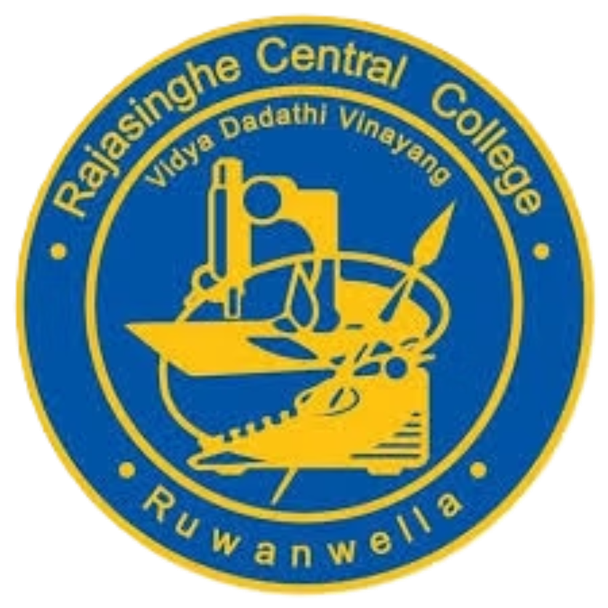

Course Code: ICT 3183
Prepared By: Group 04 - Team_404
Date: April 24, 2026
- INTRODUCTION.
1.1 Purpose
The purpose of this document is to define the requirements for a web based Learning Management System (LMS) for Rajasinghe Central College. The system will digitalize academic activities such as user management, mark handling, study material sharing, and reporting.

1.2 Scope
The system will,
- Manage students, teachers, and IT/admin users
- Handle academic records (marks, classes, subjects)
- Provide study materials (PDF & YouTube links)
- Generate reports for students, teachers, and administration
- Support bilingual education (Sinhala & English)
- Provide a public school website.

1.3 Intended Audience
- Project supervisor / lecturers
- Development team
- School administration

1.4 Technologies Used
- Frontend: React.js
- Backend: SpringBoot
- Database: mysql
- File Storage: Cloud base

- OVERALL DESCRIPTION
2.1 Product Perspective
The LMS is a standalone web-based system integrated with the school environment, replacing manual record-keeping with a centralized digital platform.

    - Use Case Diagram
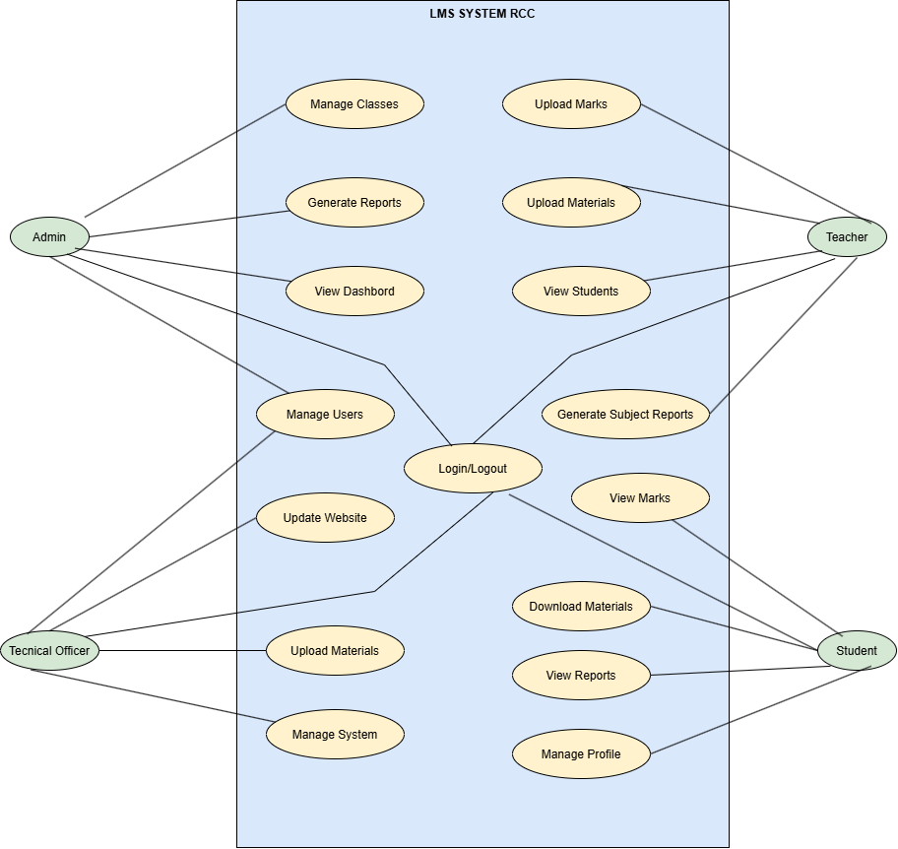

2.2 User Classes and Characteristics
Admin
- Full system control
- User and class management
- Report generation

IT Section/technical officer
- Manage users and classes
- Update website content
- System maintenance

Teacher
- Upload marks
- Upload study materials
- View student performance

Student
- View marks and materials
- Access reports (parent view)
- Manage profile

2.3 Operating Environment
- Web-based system
- Runs on modern browsers (Chrome,Edge)
- Cloud-hosted backend and database

2.4 Design Constraints
- Only Admin/Technical Officer can create users
- Users cannot change username/password
- Must be responsive for mobile devices

2.5 Assumptions
- Users have internet access
- School staff will be trained to use system
- Cloud hosting services will be available

2.6 System Development Methodology
The system is developed using the Agile software development methodology. Agile is used because it allows flexible and step-by-step development of the system. It supports continuous improvement and changes in requirements during the project.
The Scrum approach is followed, where the system is developed in small parts called sprints. Each sprint delivers a working module such as user management, marks management, or report generation. This method helps in better planning, teamwork, and faster development.

- FUNCTIONAL REQUIREMENTS
3.1 User Management
- The system shall allow Admin and IT Section to add new users (Teachers and Students).
- The system shall allow Admin and IT Section to remove existing users.
- The system shall assign roles to users (Admin, IT, Teacher, Student).
- The system shall display user profiles based on role access.
- The system shall enforce a school hierarchy where higher roles have controlled administrative authority over lower roles.

3.2 Authentication System
- The system shall provide secure login for all users.
- The system shall authenticate users using username and password.
- The system shall restrict access based on user roles.
- The system shall not allow users to change their username or password. Only Admin or Technical Officer can reset user passwords for security purposes

3.3 Class Management
- The system shall allow Admin and IT Section to create and manage classes (Grade 6–11).
- The system shall allow assignment of students to classes manually.
- The system shall allow viewing of class details and student lists.

3.4 Subject Management
- The system shall allow creation and assignment of subjects to classes.
- The system shall allow assigning teachers to subjects.
- The system shall support Sinhala and English medium subjects.

3.5 Marks Management
- The system shall allow teachers to upload student marks.
- The system shall allow students to view their marks.
- The system shall store term-based marks (Term 1, Term 2, Term 3).
- The system shall calculate and display performance reports.

3.6 Study Material Management
- The system shall allow teachers to upload study materials in PDF format.
- The system shall allow teachers to add YouTube video links.
- The system shall allow students to download and view study materials.

3.7 Report Generation
  - The system shall generate student performance reports.
  - The system shall generate class-wise academic reports.
  - The system shall generate overall school reports for Admin and IT Section.
  - The system shall allow students to view reports for parent reference.

3.8 School Website Management
- The system shall provide a public school website.
- The system shall display pages such as Home, Academic, Sports, Events, and Contact.
- The system shall allow IT Section to update website content.

3.9 Student Profile Management
- The system shall allow students to view their profiles.
- The system shall allow Admin/Technical Officer to update student information.
- The system shall store student academic details securely.

3.10 External Integration
- The system shall support embedding YouTube videos.
- The system shall support PDF document uploads and downloads.

- NON-FUNCTIONAL REQUIREMENTS
4.1 Performance Requirements
- The system shall respond to user requests within less than 5 second.
- The system shall support multiple users accessing simultaneously.
- The system shall optimize database queries for fast data retrieval.

4.2 Security Requirements
- The system shall encrypt all passwords using secure hashing .
- The system shall implement role-based access control.
- The system shall prevent unauthorized access to sensitive data.

4.3 Usability Requirements
- The system shall provide a user-friendly interface.
- The system shall have simple navigation for all user types.
- The system shall be easy to use for non-technical school staff.

4.4 Reliability Requirements
- The system shall be available 24/7 through cloud hosting.
- The system shall ensure data consistency and backup.

4.5 Scalability Requirements
- The system shall support expansion to more grades and students.
- The system architecture shall allow adding new features easily.

4.6 Maintainability Requirements
- The system shall follow mvc architecture.
- The system shall separate frontend and backend clearly.
- The system shall allow easy updates and bug fixes.

4.7 Compatibility Requirements
- The system shall run on modern web browsers.
- The system shall be responsive on mobile, tablet, and desktop devices.

4.8 Deployment Requirements
- The system shall be deployed on cloud base platform.
- The system shall use mysql for database hosting.

- SYSTEM ARCHITECTURE
5.1 Architecture Model
React Frontend SpringBoot backend mysql Database

5.2 Components
- Frontend (React UI)
- Backend (SpringBoot)
- Database (Mysql)
- Cloud Storage

- DATABASE REQUIREMENTS
- User
- Admin
- Student
- Teacher
- Technical Officer
- Class
- Subject
- Mark
- Document
- Report.
6.1 ER Diagram
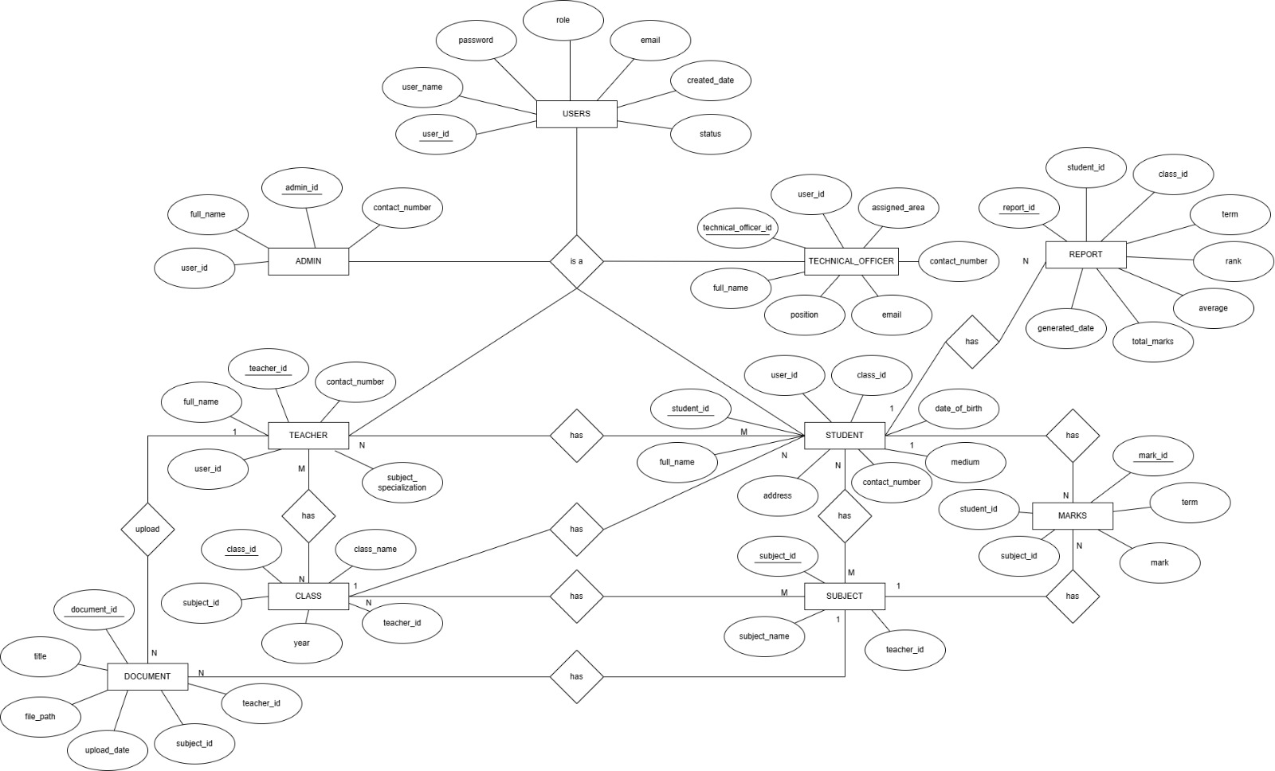

- USER ROLES AND PERMISSIONS
Feature | Admin | T.O | Teacher | Student
Manage Users | Can | Can | Can not | Can not
Manage Classes | Can | Can | Can not | Can not
Upload Marks | Can not | Can not | Can | Can not
View Marks | Can | Can | Can | Can
Upload Study Materials | Can not | Can not | Can | Can not
View Reports | Can | Can | Can | Can

- SYSTEM REQUIREMENTS
8.1 Hardware
- Standard server or cloud hosting
- 2GB RAM minimum (development)

8.2 Software
- SpringBoot
- Mysql
- React.js
- Browser should support

- SYSTEM LIMITATIONS
- Requires internet connection
- No offline mode
- Requires user training

- FUTURE ENHANCEMENTS
- Live class streaming
- Online examinations system
- Parent login portal

- CONCLUSION
The proposed Learning Management System for Rajasinghe Central College is a simple and useful web system to manage school activities. It helps to store and handle student, teacher, and academic information in one place. This system reduces manual work, improves communication, and makes learning easier for students through a digital platform.

